
GIS Library Tutorials – Introduction to ArcGIS Online - 11

MapGenie - Getting Started : Connect to MapGenie

Left click on the Add Data option (clicking on either the + symbol, the word Add or the pull-down arrow will open the same menu of options)

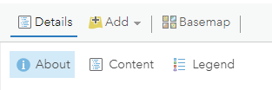

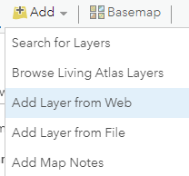
Left click on Search for Layers

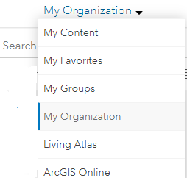
At the pull-down menu left click on My Organization

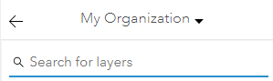
This opens Search for layers

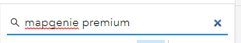
Type the words mapgenie premium and press return on your keyboard

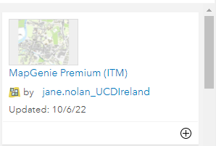
Left click on the blue title

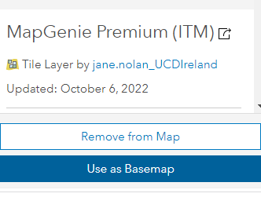
Left click on Use as Basemap

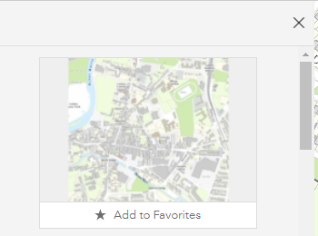
Left click on X to close the window

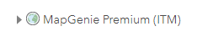
MapGenie Premium is now listed within Content pane and the map is shown in the viewer

Keep left clicking on the + button to zoom into the map to view the basemap at its full scale
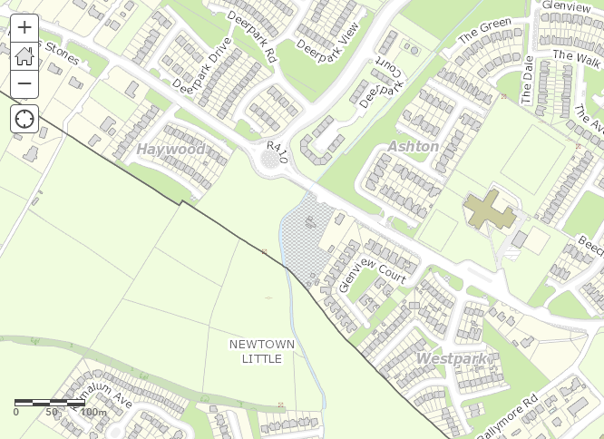
The scale bar in the bottom left will show the measurement of 100 metres
Along the top of the map left click on Save and from the menu left click on Save

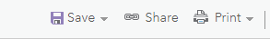

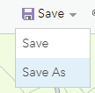

Here are the mapping series available in MapGenie
